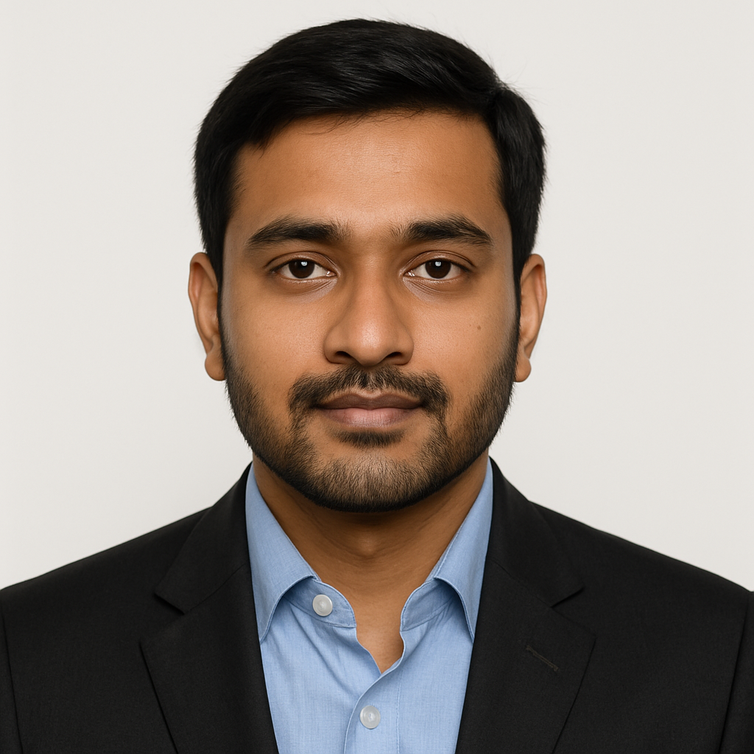
SUMMARY
Highly motivated Computer Science graduate with strong foundations in data structures, algorithms, and full-stack development. Passionate about coding, problem-solving, and building scalable software solutions. Seeking an entry-level Software Engineer role to apply my technical skills and grow within a dynamic development environment.
HOBBIES
Blogging Chess Writing
Photography Reading Public Speaking
Badminton Travelling Cricket
PROJECTS
Smart Attendance System (Python + OpenCV)
- Built a face-recognition-based attendance tracking system.
- Utilized OpenCV for image capture and SQLite for data storage.
- Achieved 95% recognition accuracy on local dataset.
SKILLS
- Programming: Python, Java, C++
- Web Technologies: HTML, CSS, JavaScript, React.js, Node.js
- Database: MySQL, MongoDB
- Tools & Platforms: Git, GitHub, VS Code, Postman, JIRA
CERTIFICATES

- Google Data Analytics Certificate – Coursera
- Python for Everybody – University of Michigan (Coursera)
EDUCATION
Degree | Institution | Year | CGPA / %
B.Tech – CSE | PES University, Bengaluru | 2025 | 8.3 / 10
Class XII – CBSE | Kendriya Vidyalaya, Bengaluru | 2021 | 88%
Class X – CBSE | Kendriya Vidyalaya, Bengaluru | 2019 | 90%

Rohan Sharma
Software Developer

LANGUAGES

- English: Fluent
- Hindi: Native
CONTACT

Email
rohan.sharma@email.com

Phone
+91 98 7654 3210

Address
Bengaluru, India
LinkedIn
linkedin.com/in/rohan

